1. Adding Sector

Post method on Sector and viewing the data is shown in H2-console.

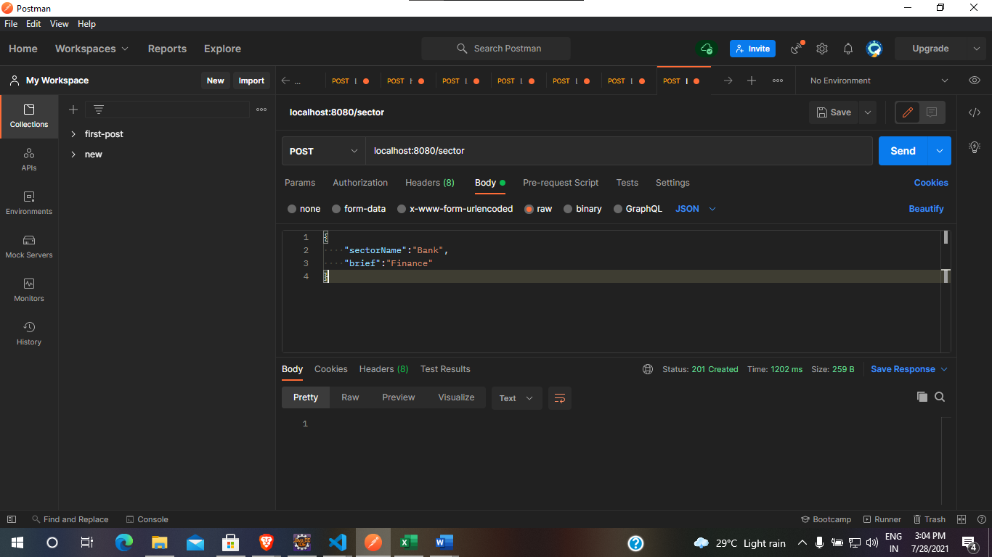

H2-Console to view the post method of Sector

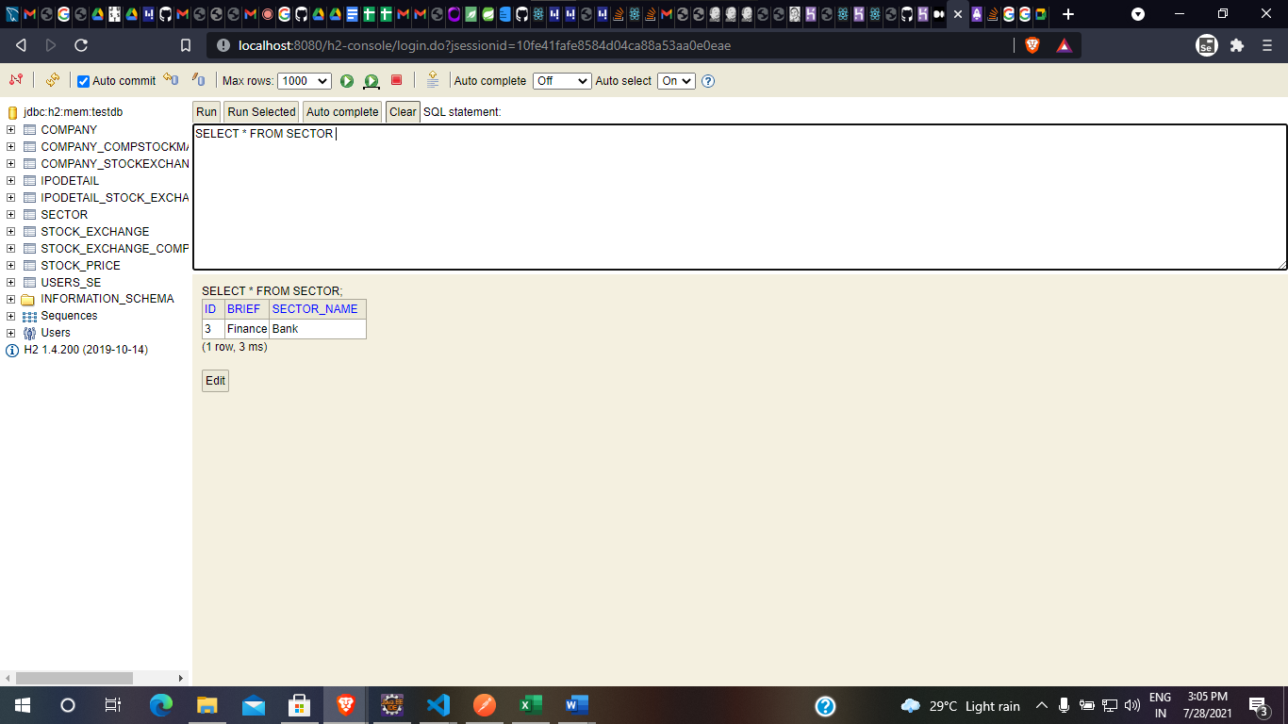

1. Adding Company

Post Method for Company and Updating the company’s Sector

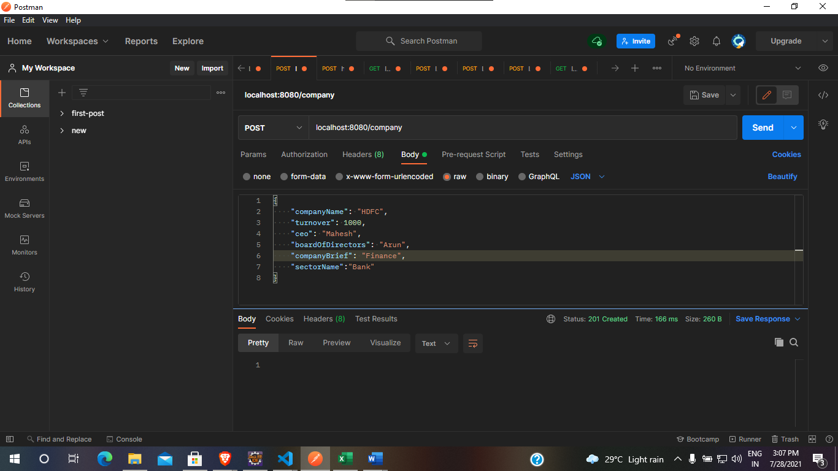

H2-console to view the data updated into company table along with the Sector ID and Sector Name, The starting two companies are automatically loaded into the database during init.

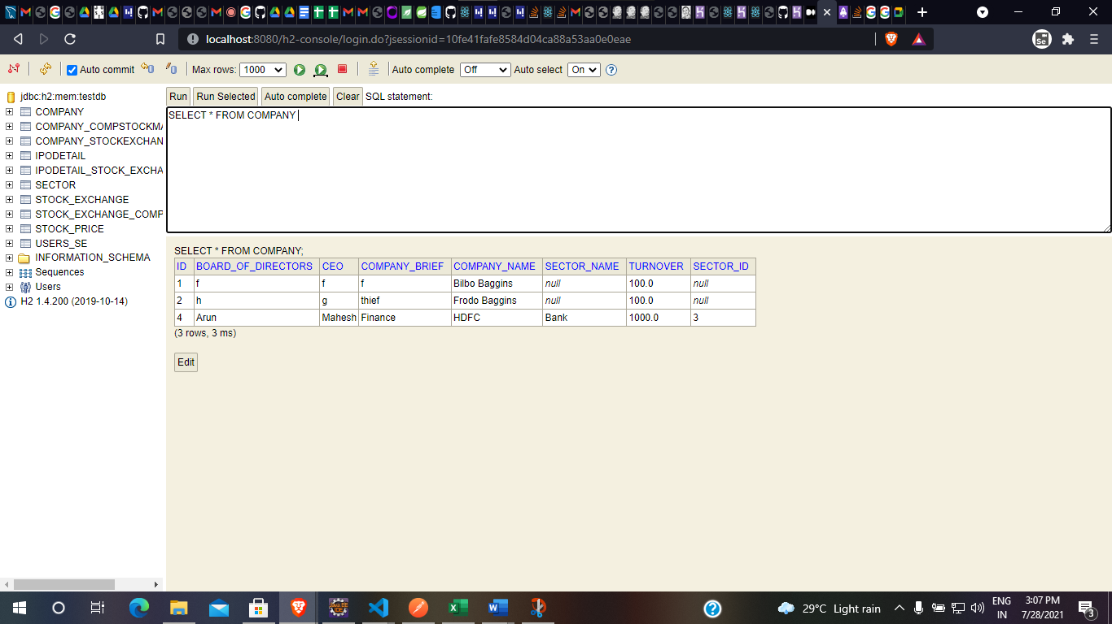

1. Adding Exchange Name

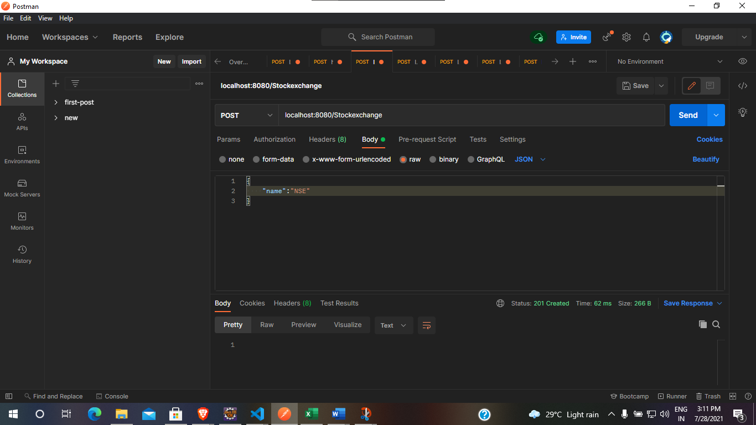

H2 – console to display Exchange Name

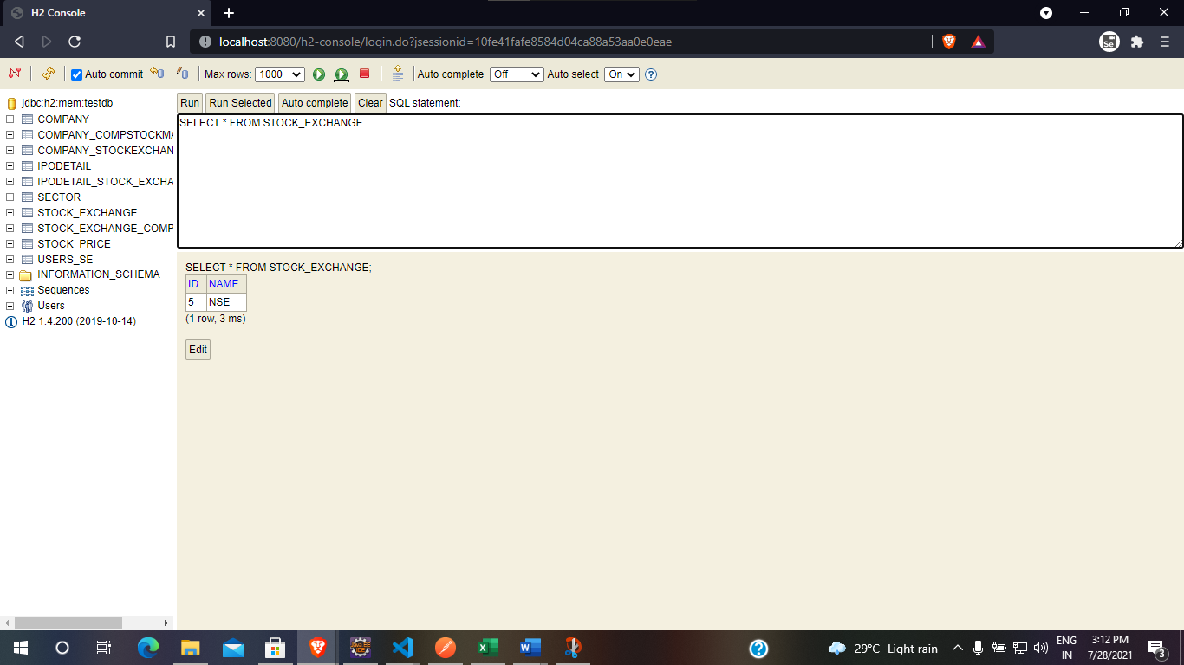

1. Map between Exchange and Company

Company Code must be provided, company name must be selected from the created company and applies same for exchange name as well

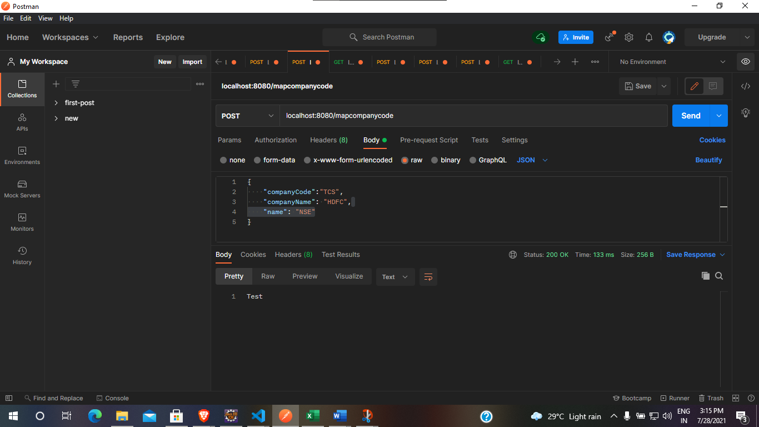

H2 – console – Shows the mapping between Company and Exchange and has TCS as company code

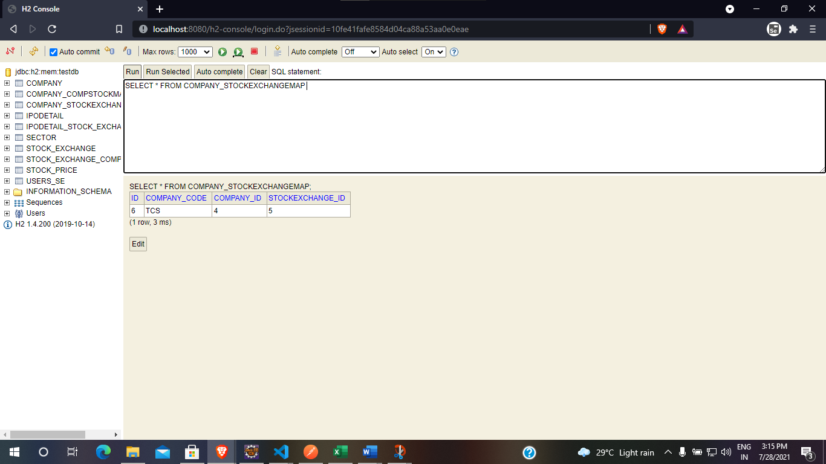

1. Adding stock Prices

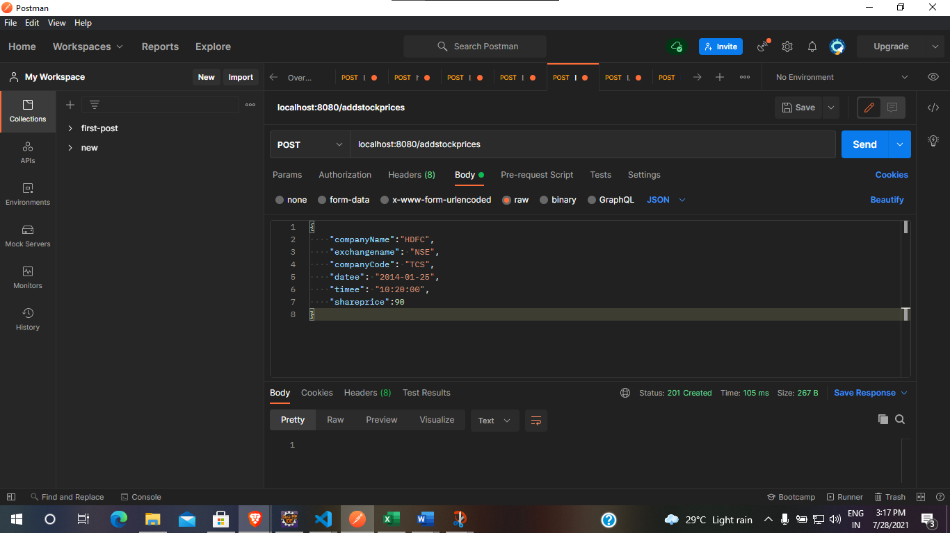

H2 – console – Showing the stock price(Share price attribute) for a particular Company and Company Code

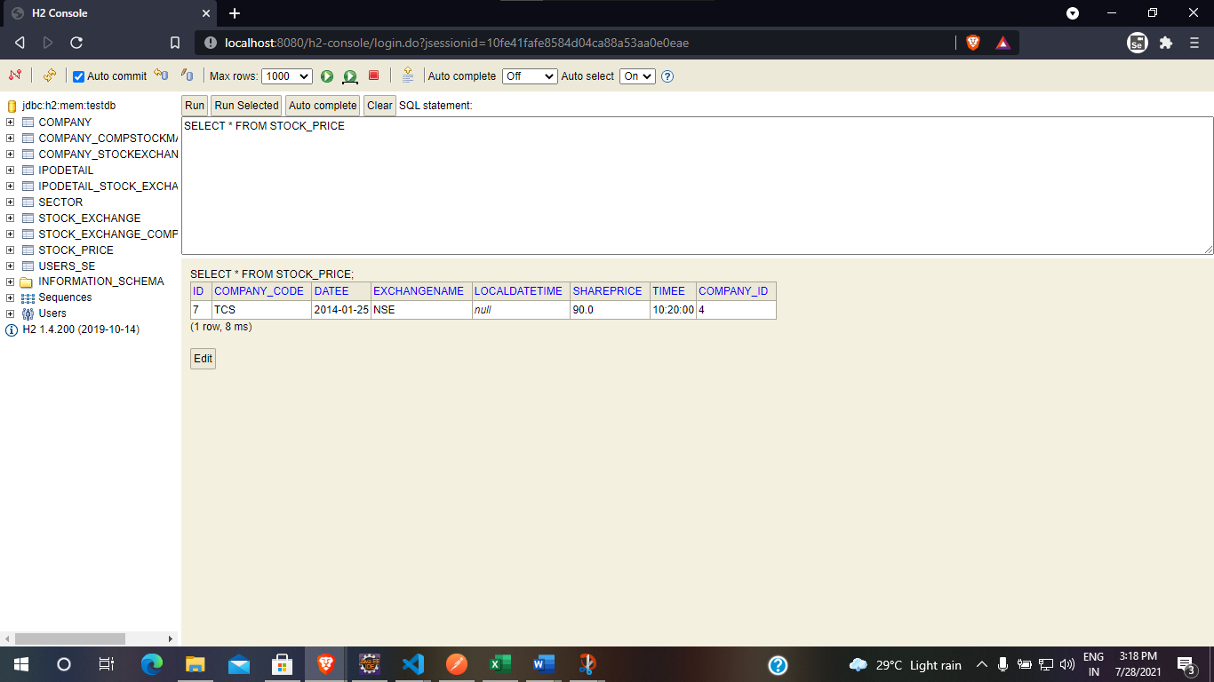

1. Adding IPO Details

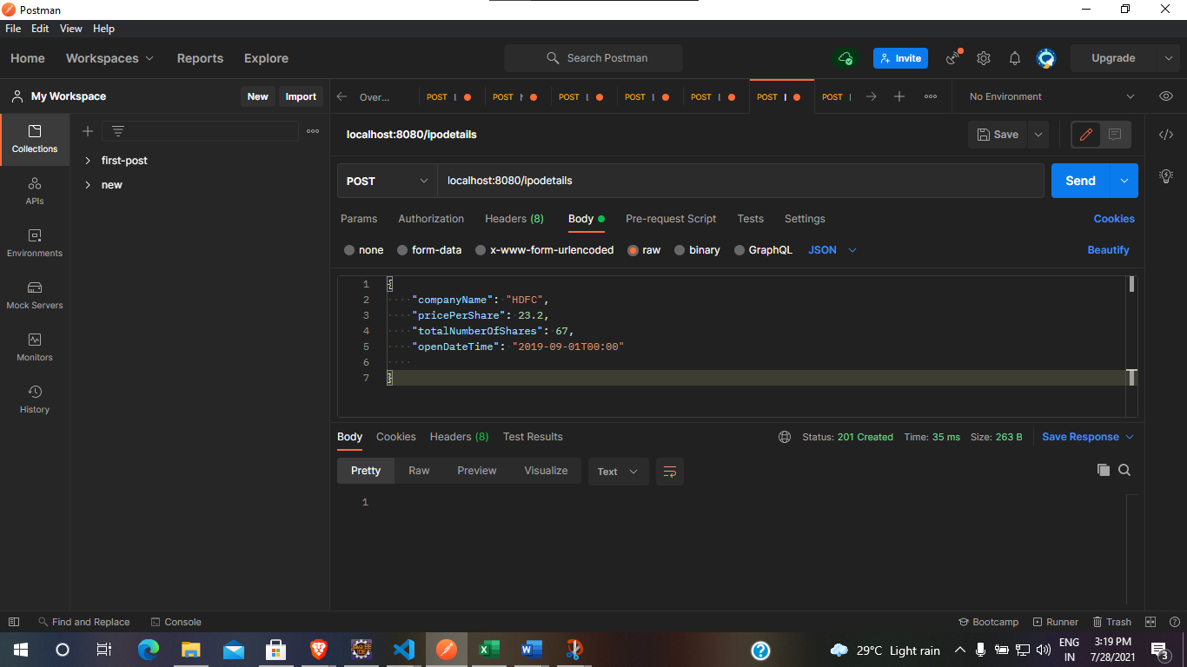

H2- console to show the ipdetails

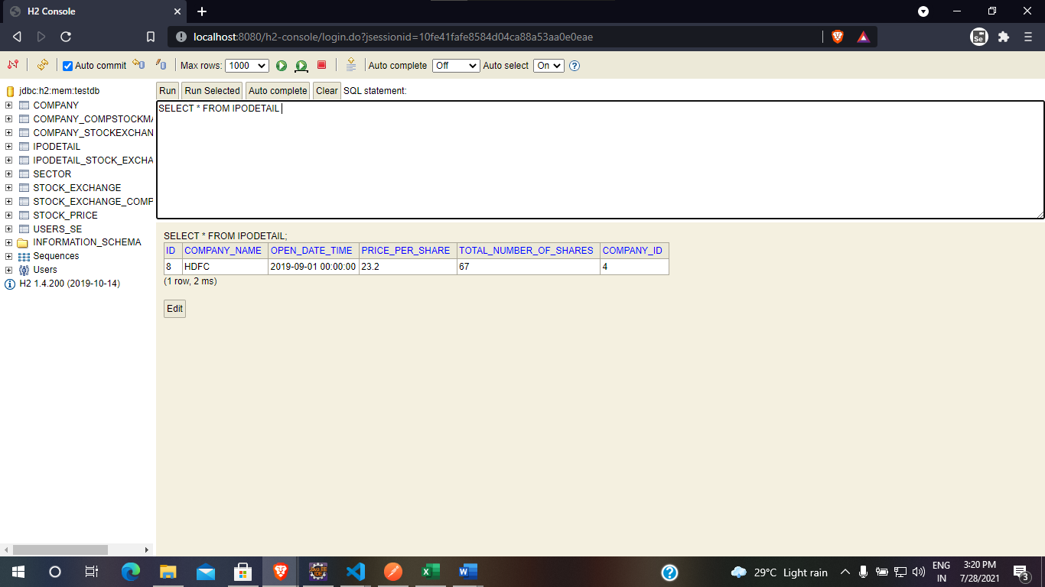

1. Get Stock Prices

Get method to obtain all the stock prices was implemented, same as the added stock price

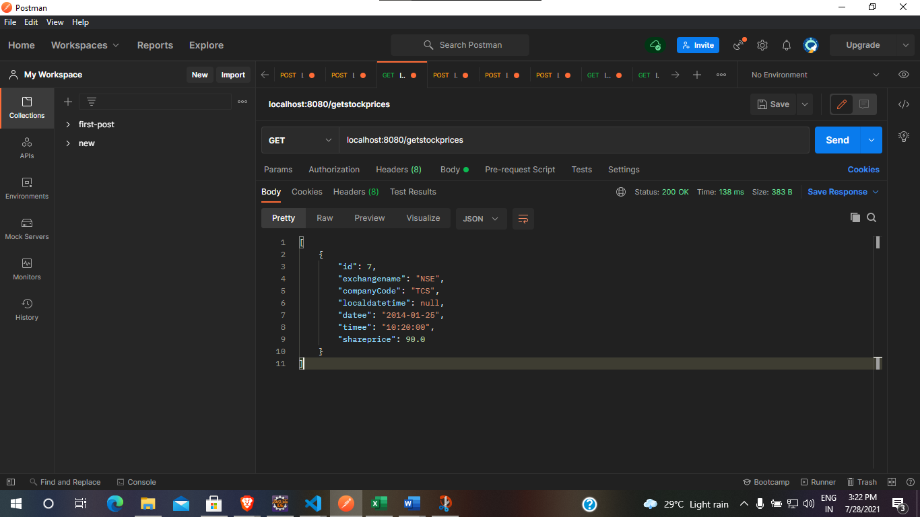

1. Get Company by ID - Used post method to send ID of a company and received the particular Company

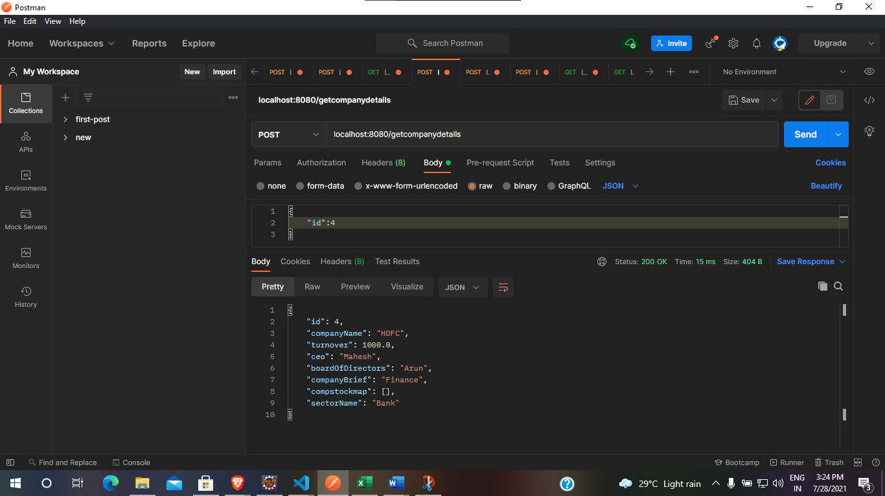

1. Get IPO Details from Company Name:

Sending HDFC to get IPO details of HDFC

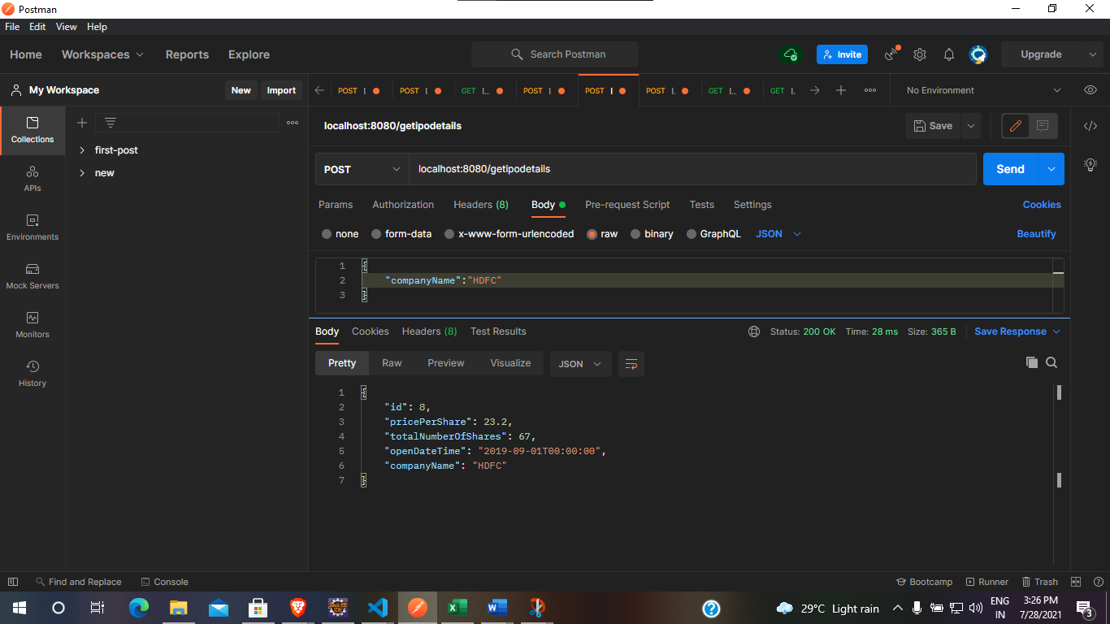

1. Get Company from Sector Name

Sending Sector name and obtaining all the list of companies in that sector

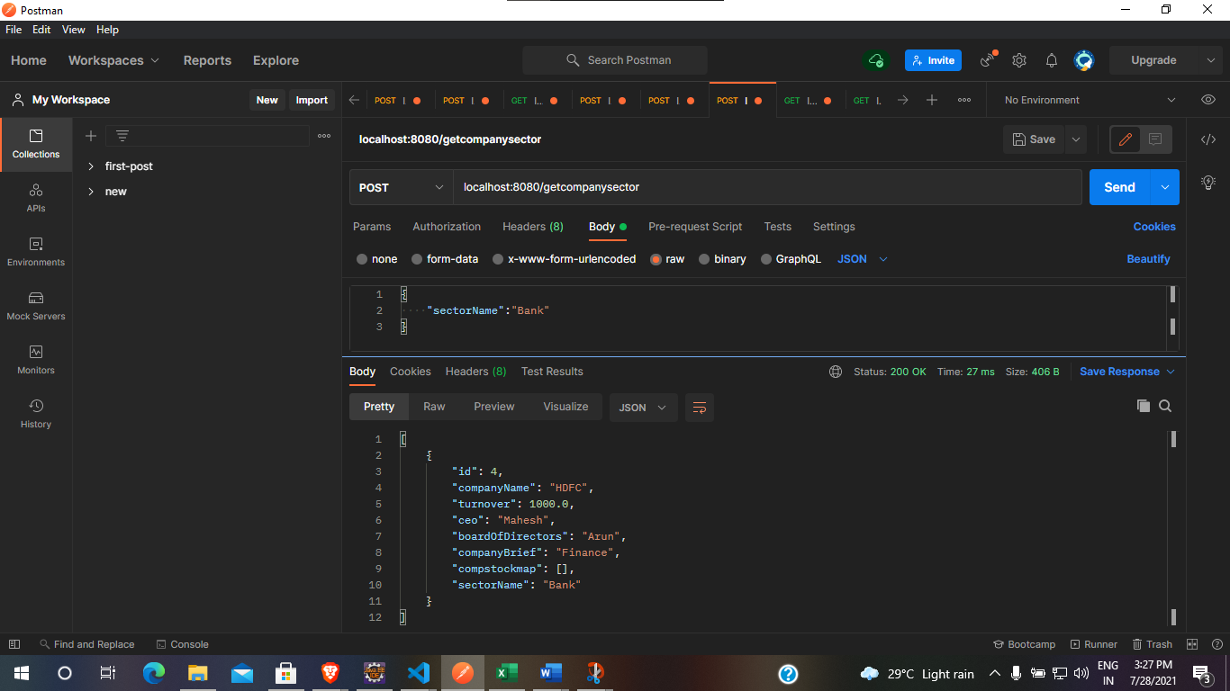

1. Get Stock Exchange

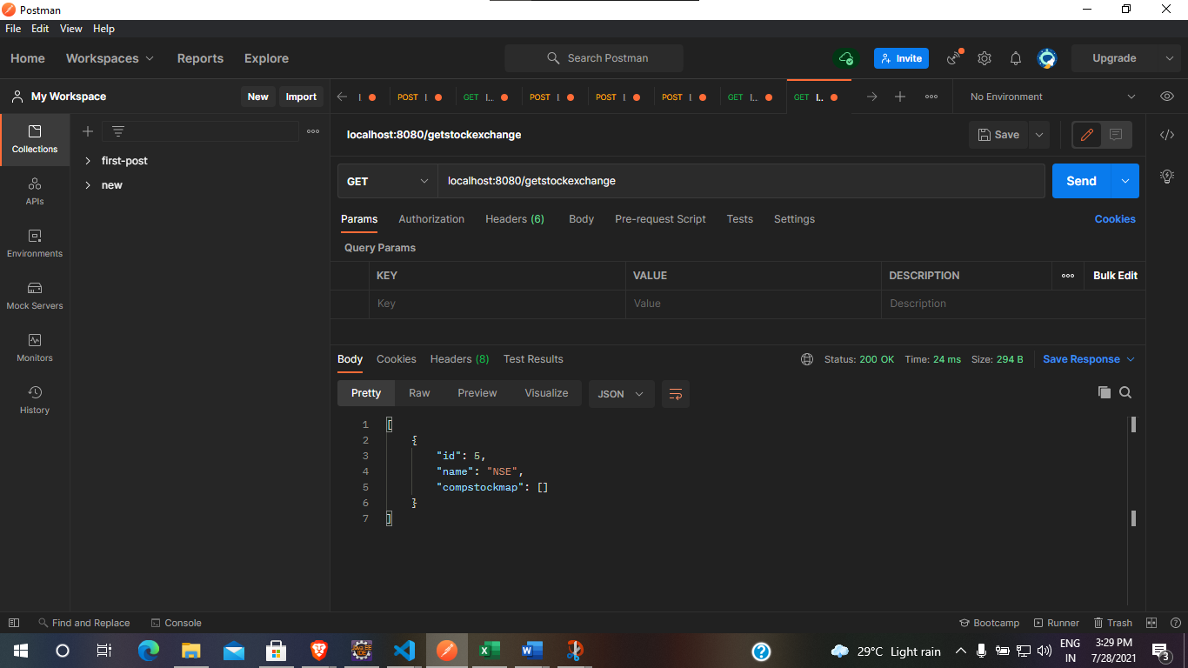

1. Get Companies from Exchange Name

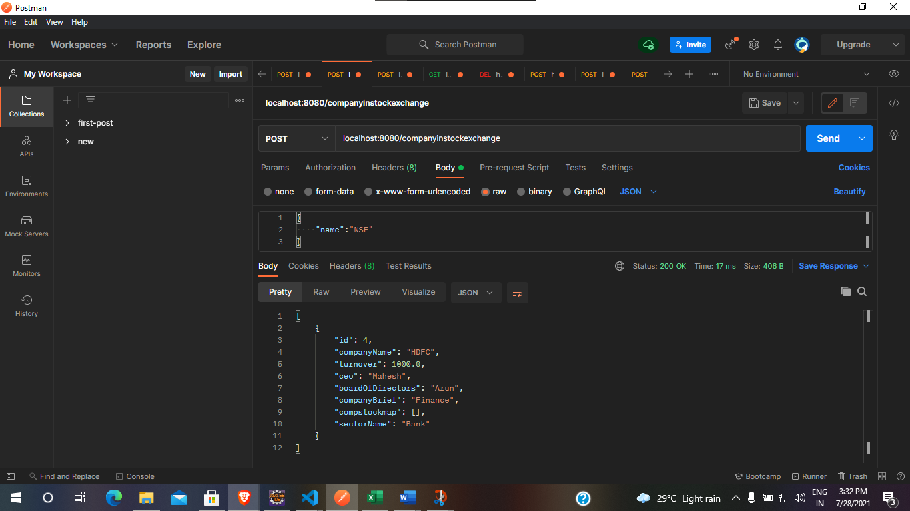

1. Get Stock Prices

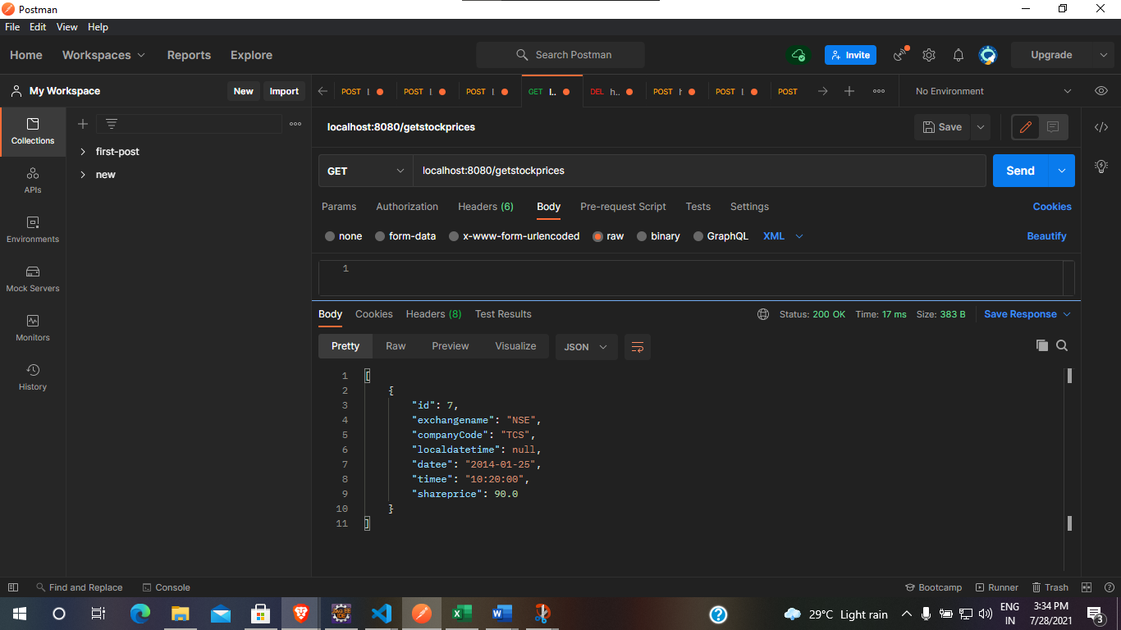

1. Get Company details of particular exchange, given from and to Date

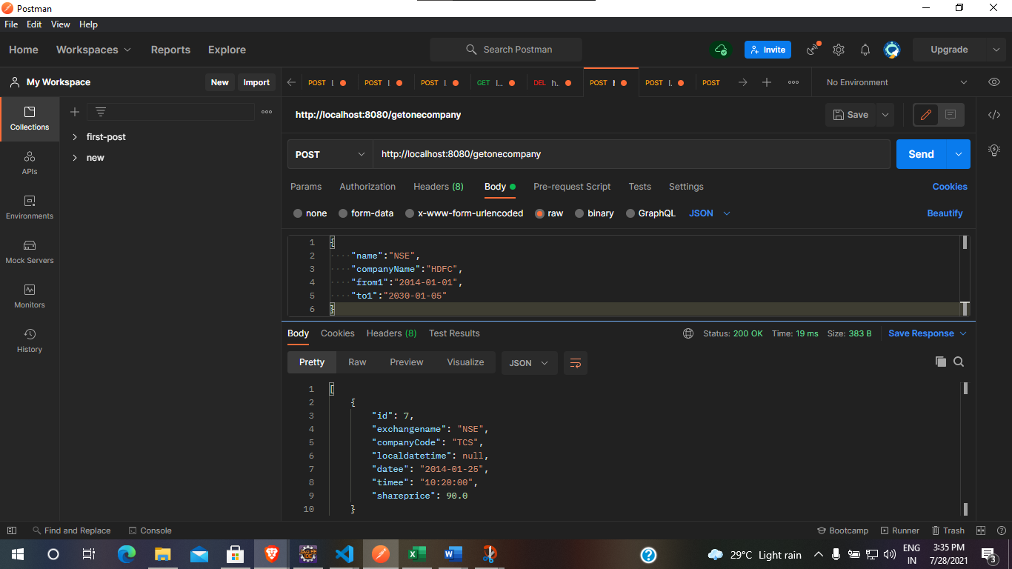

1. Comparison between 2 Companies

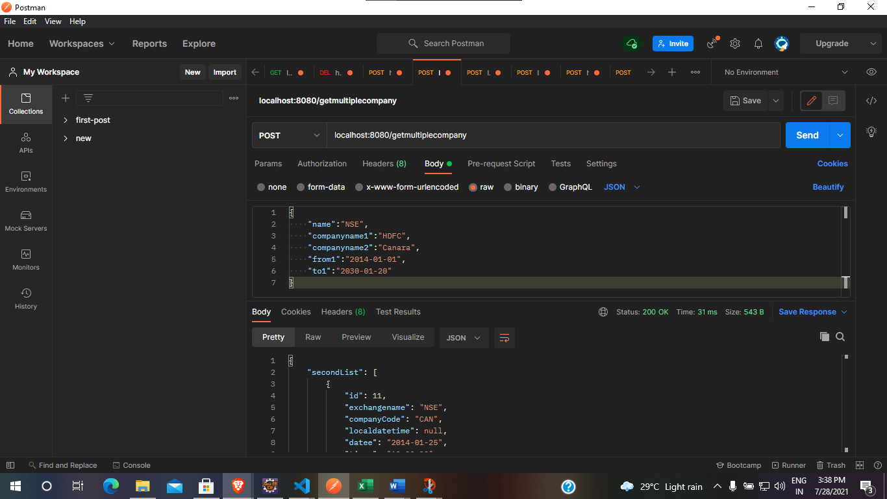

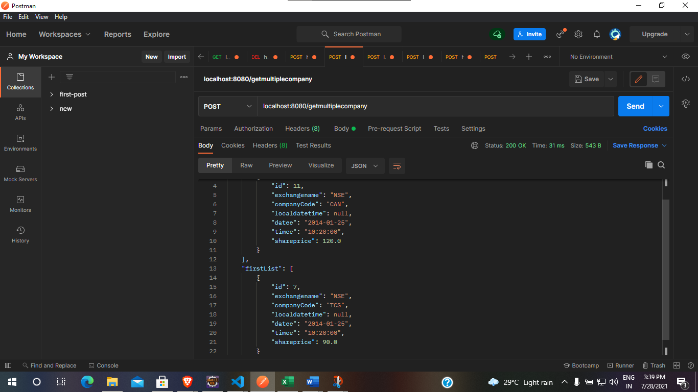

1. Get Company Details By Name

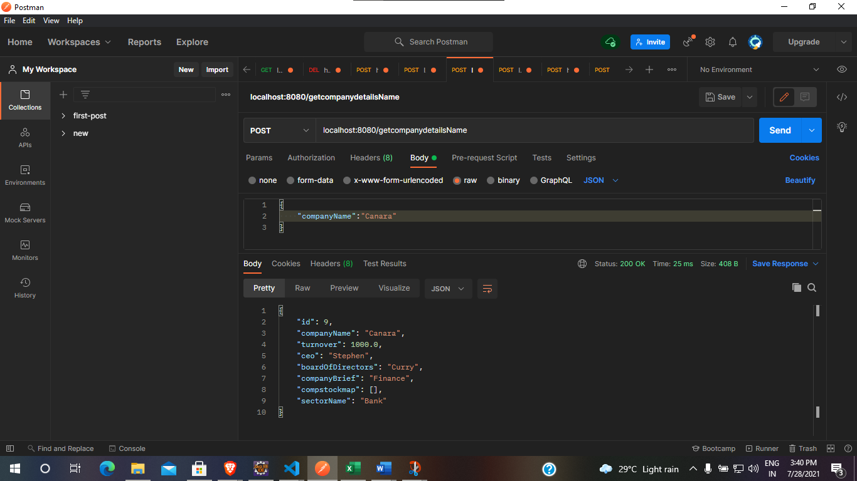

1. Set User – Before Confirmation from GMAIL

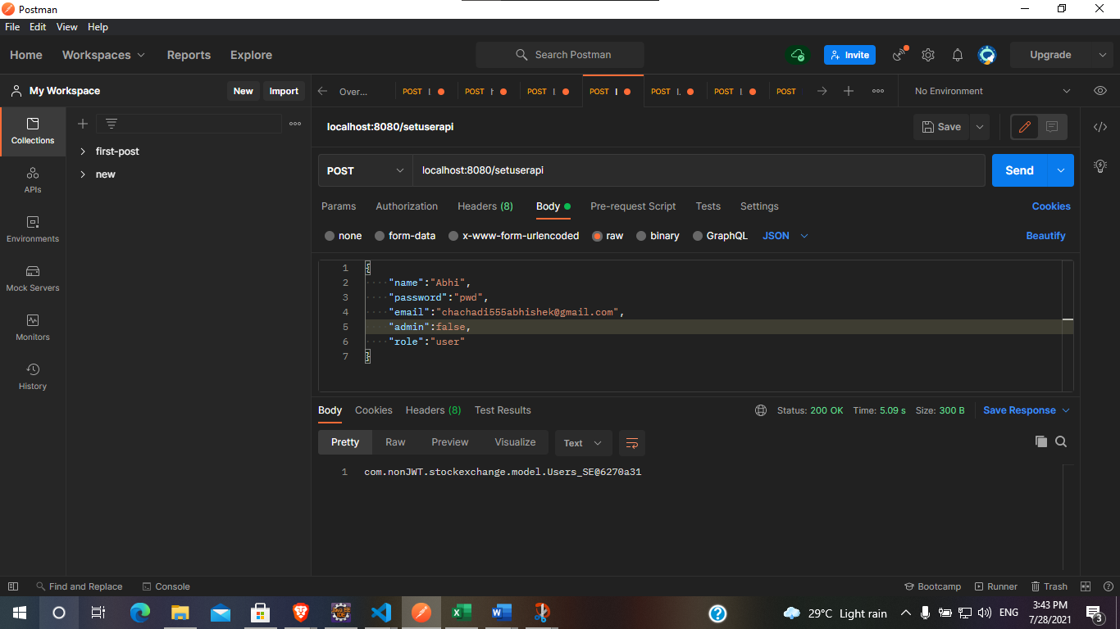

As you can see, confirmed is null initially, it should be confirmed from the Gmail by clicking the link, shown In the next snapshots.

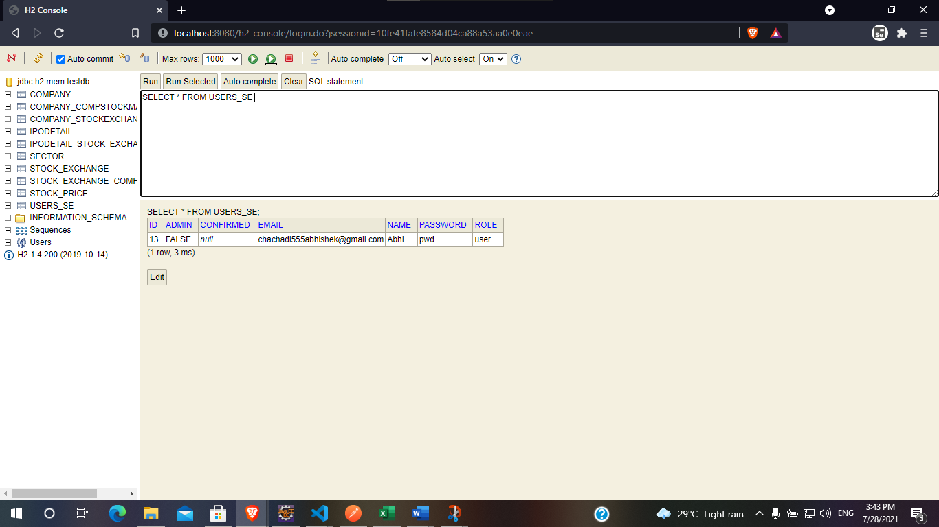

GMAIL – LINK

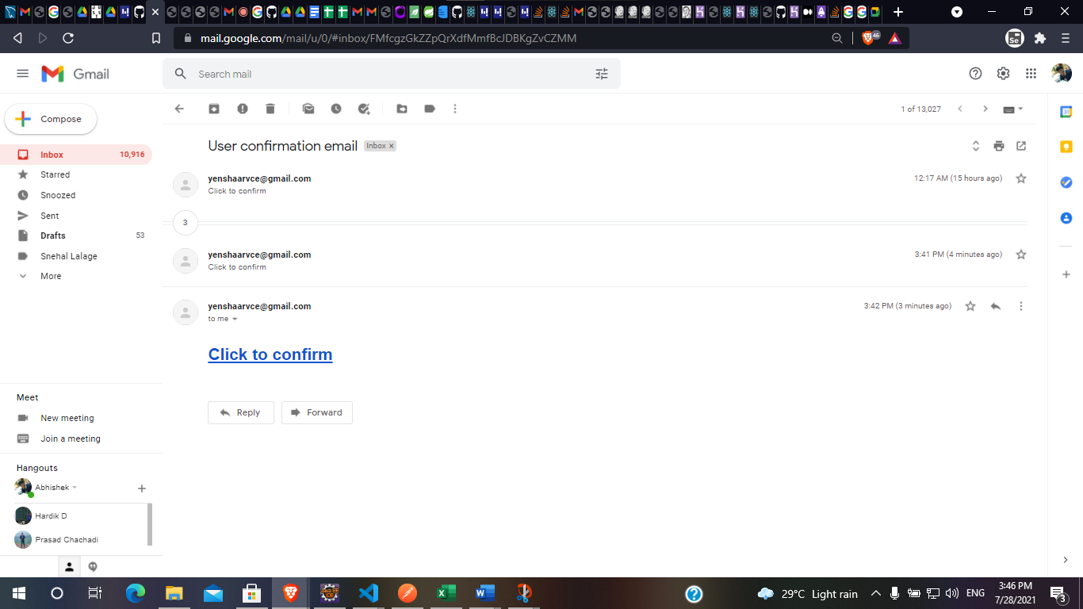

Confirmation

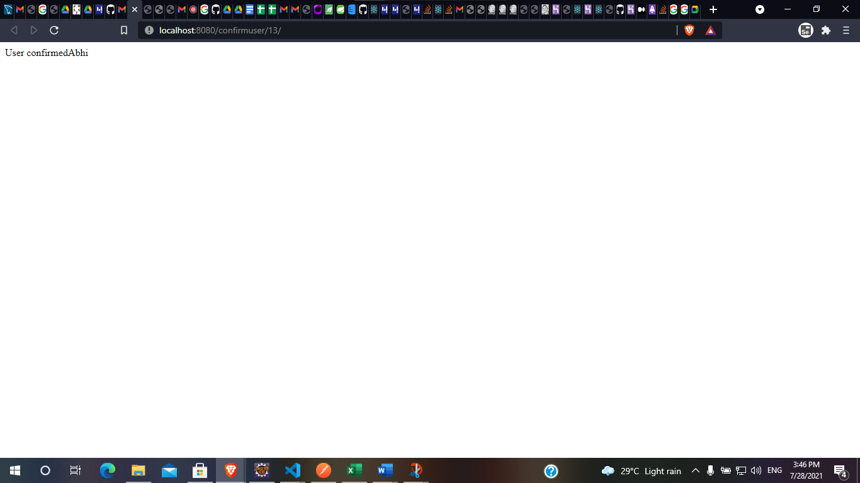

H2-Console – Confirmation

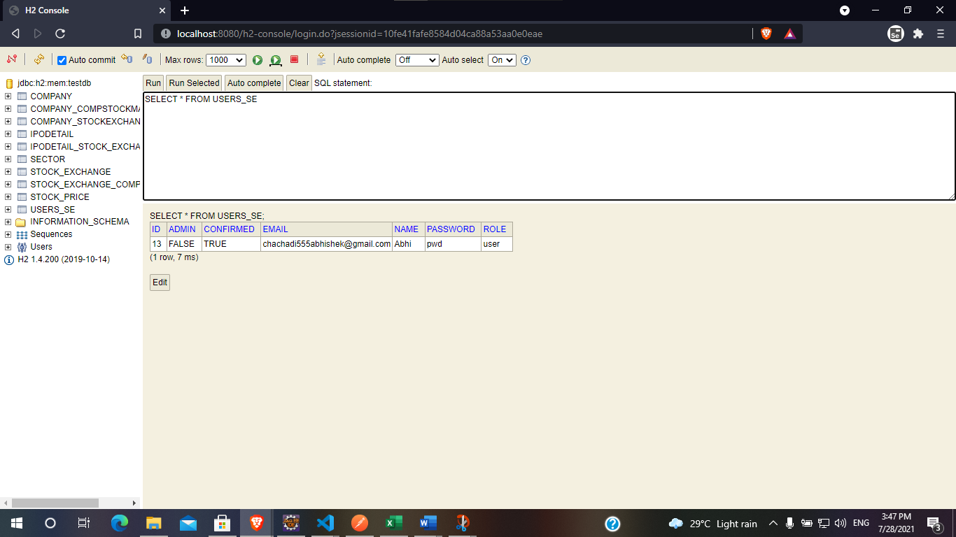

1. Get Users

